NEDU Facilities

Ocean Simulation Facility (OSF)

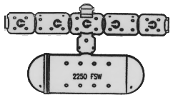

The OSF is a one of a kind, national asset capable of pressurization to a maximum depth of 2250 feet sea water (fsw). It consists of a series of five interconnected dry chambers capable of accommodating up to 8 test subjects during saturation, diving and research evolutions. The 3,300 cubic foot system houses a 47 ft long 55,000 gallon wet chamber that has an operating temperature range of 28F to 104F. This facility can also be used as an altitude chamber with a test range in excess of 25,000 ft. Rounding out the facility is a state of the art data acquisition and storage system used to collect and analyze a wide range of information, from biomedical experiments to complex user/equipment interface testing.

Experimental Diving Facility (EDF)

The EDF houses two hyperbaric chamber complexes capable of unmanned testing to 1,640 fsw and temperatures from 28°F to 104°F. Data acquisition capabilities allow for the collection of information used to analyze equipment performance and the given test parameters. The EDF has the capability to conduct acoustical analysis and off-gas testing and routinely conducts evaluations and analysis of equipment involved in diving incidents / accidents.

Test Pool

The Test Pool is a 50,000 gallon, 15-foot deep pool capable of supporting temperatures ranging from 36 ºF to 104 ºF. Equipped with state-of-the-art data acquisition instrumentation, the test pool is used for conducting a wide range of studies including thermal and physiological research and manned evaluation of diving equipment.

Gas Lab and Clean Room

We also operate a Class 100,000 certified oxygen clean facility that provides on-site oxygen cleaning services as well as the test and manufacture of high pressure hoses and equipment required for all of NEDU's operations. In addition, this facility provides support to external customers such as the Submarine Force, Naval Special Warfare, Explosive Ordnance Disposal and Fleet Diving units.

Employment and Research

We utilize Cooperative Research and Development Agreements (CRADAs) and Interagency Personnel Agreements (IPA) to expand partnering opportunities with commercial industry and select University professionals in an effort to promote technical achievements and future development.

Want to join our team?

www.navy.com/about/navylife/onduty/navydiver/

www.supsalv.org/nedu/nedu.htm

Navy Experimental

Diving Unit

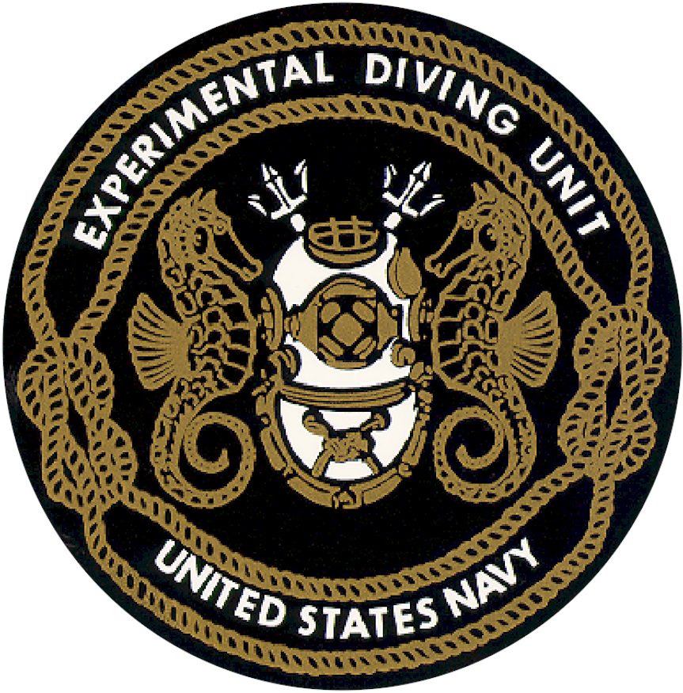

Make Diving Deep Again!

321 Bullfinch Road

Panama City, FL
32407-7015
(850) 230-3100
www.supsalv.org/nedu/
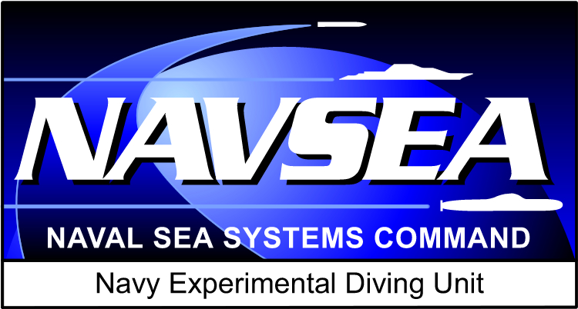

Navy Experimental Diving Unit (NEDU)
The world’s premier diving and hyperbaric research, test and evaluation unit. A field activity of Naval Sea Systems Command (NAVSEA) which reports to the Director of Ocean Engineering, Salvage and Diving (SEA 00C). Located on the northern coast of the Gulf of Mexico in Panama City, Florida, NEDU is a tenant command of Naval Support Activity - Panama City (NSA-PC).

NEDU Mission
Navy Experimental Diving Unit (NEDU) partners with the warfighter to develop timely, cost-effective solutions to support and improve manned operations in undersea and other extreme environments through biomedical research and independent testing and evaluation of equipment and procedures.

NEDU Vision
NEDU will be the partner of choice for:
- Strategic planning and alignment for undersea and extreme environment research, development, testing and evaluation efforts.
- Helping our customers define requirements and develop technical solutions for transition to the warfighter.

The NEDU Team
The NEDU team is composed of a highly qualified and experienced group of military divers, world-renowned university scientists, a diving medical department with the foremost medical expertise, civilian technicians with industrial and diving experience, administrative and support personnel and numerous technical contractors and consultants with ties to the ocean industry. Combined, the NEDU team has over 1,000 man-years of experience and technical expertise in the field of diving.

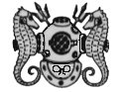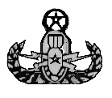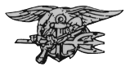

Diving Support
We liaise with NAVSEA and operational diving units across all military services and government agencies to test and evaluate the suitability of commercially available diving equipment to meet the requirements of our various customers. The requirements differ sharply from ship’s husbandry to EOD and saturation diving to SOF combat swimmers. We continually survey equipment improvements and evaluate advances in technology for uses in the widely varying missions of the diving community. We are able to simulate mission profiles ranging from the deepest depths, coldest water and the strongest currents, in order to evaluate equipment, procedures and/or human endurance in the most extreme environments, and provide customized solutions to unique warfighter demands, in a minimum amount of time.

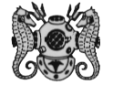

Diving Medicine
Our Diving Medical expertise includes a comprehensive staff of navy trained Diving Medical Officers, research psychologists and physiologists. We provide 24 hour worldwide consultation for diving emergencies.

RDT&E
We conduct manned biomedical Research, Development, Test, and Evaluation (RDT&E). By combining rigorous scientific discipline with operational experience, we enhance diving safety and performance resulting in longer, deeper, safer and more flexible diving capabilities. We continually explore new technologies that pose a potential benefit for improving diving and extreme environment operational capabilities.

At NEDU we push the envelope of technology to identify breakthrough capabilities. Recent studies and advances include:

- Accelerated decompression utilizing oxygen
- Decompression schedule development
- Defining O₂ toxicity limits
- Active thermal protective systems for cold water diving applications
- CO₂ scrubber capacity monitor
- Gas Mask work-load limitations
- Evaluation of the Next-Generation UBA
- Active Anti-Swimmer defense systems
- Real-time, inline air quality monitoring

